Organization and Architecture Computer

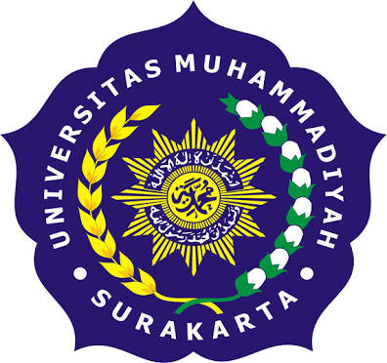

Tri utomo

L200154006

X class

UNIVERSITAS MUHAMMADIYAH SURAKARTA

**Motherboard support for 5th generation.**

-Asus Motherboard

ASUS P8Z77-V LK Motherboard(Socket 1155, 32GB DDR3 Support, ATX, Intel Z77 Express, USB 3.0, CrossFireX & SLI Support, Display Port, Dual Intelligent Processors 3).

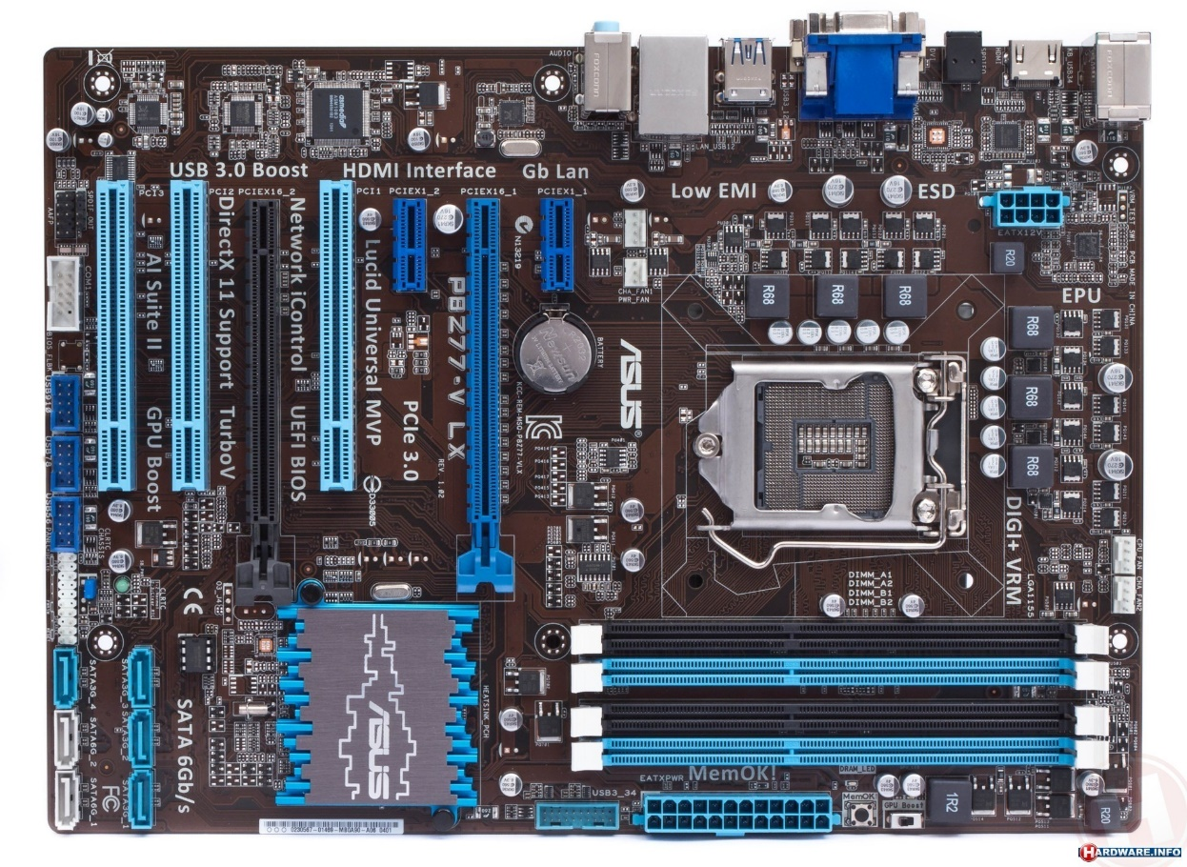

Description & detail features :

* The intel Z77 express single chipset design to support LGA 1155 socket for 3rd generation also can support in 5rd generation.
* Z77 chipset provides 4 USB 3.0 ports for 10 times faster data retrieval speed.
* 2-channel (4 DIMM) DDR3 memory and 16 PCI express 3.0/2.0 lanes. This features provides great graphics performance.
* DIGI + VRM digital power design.
* USB 3.0 Boost – faster USB 3.0 transmission with UASP(170%).
* Network iControl – Real time network bandwidth control.
* LucidLogix virtu universal MVPTM Up to 60% hybrid graphics boost.
* Quad GPU SLI and Quad GPU/3 way CrossFireX support.
* Memory type : DDR3 SDRAM
* 2 of number USB 2.0 ports.
* Voltage : 1.5 volts.
* CPU technology Turbo boost 2.0
* Max memory supported : 32 GB

-Gigabyte Motherboard

Gigabyte Z97P-D3 Intel LGA1150 Z97 ATX Motherboard.

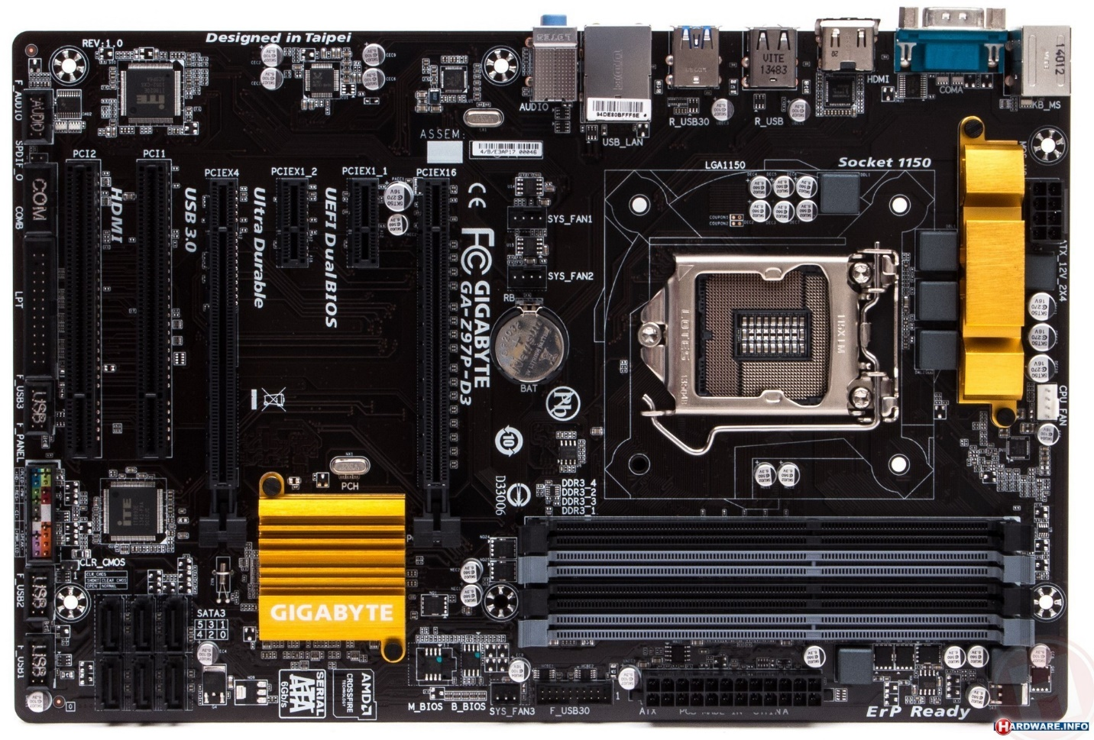

Description & detail features :

* Support 4th an 5th generation Intel Core Processors.
* Dual channel DDR (4DIMMs).
* M.2 for SSD drives with up to 10Gb/s data transfer.
* Realtek ALC1150 115dB SNR HD audio with built-in rear audio amplifier.
* Killer E2200 gaming networking.
* Processor socket : LGA 1150.
* Computer Memory Type : DDR3 SDRAM.
* Number of serial ports : 1
* Number of USB 2.0 ports : 4
* CPU technology Turbo boost 2.0
* Max memory supported : 32 GB

Motherboard support for 7th generation

-Gigabyte Motherboard H81M-S1 socket 1150

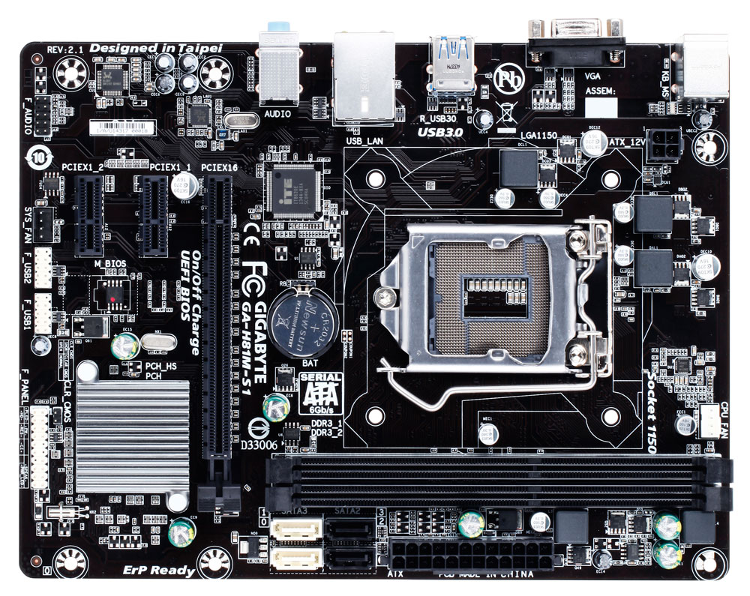

Description & detail features :

* Support for intel core i7 processors.
* 2 x 1.5 V DDR3 DIMM sockets supporting up to 16 GB of system memory.
* Dual channel memory architecture.
* Support for DDR3 1600/1333 MHz memory modules.
* Support for Non-ECC memory modules.
* Support for Extreme Memory Profile(XMP) memory modules.
* Solid capacitors for CPU VRM design.
* USB 3.0 ports with Gigabyte 3x USB power.
* Maximum memory supported : 64 GB.
* CPU technology Turbo boost 2.0

-ASRock Motherboard H110 Pro BTC+

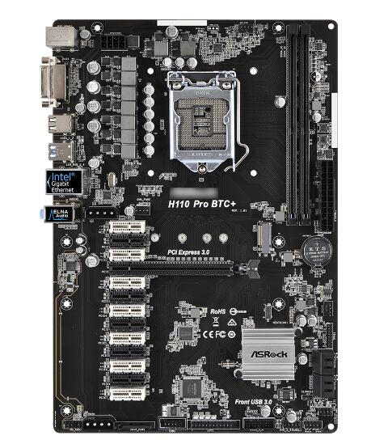

Description & detail features :

* Support for 7th and 6th generation intel core i7/i5/i3 pentium/Celeron processors (socket 1151).
* Supports DDR4 2400/2133.
* 4 USB 3.0(2 front, 2 rear).
* Dual channel DDR4 memory technology.
* 2 x DDR4 DIMM slots.
* Max capacity of system memory 32Gb*.
* 64 Mb AMI UEFI legal BIOS with multilingual GUI support.
* SMBIOS 2.7 support.
* 8 power phase design.
* Max shared memory 1024Mb**
* CPU technology Turbo boost 2.0

Comparison

|  |  |  |  |  |  |
| --- | --- | --- | --- | --- | --- |
| **BRAND** | **MEMORY TYPE** | **SUPPORTED CPU TECHNOLOGIES** | **MAX. MEMORY SUPPORTED** | **SOCKET** | **SUPPORT ON GENERATION** |
| ASUS P8Z77-V LK | DDR3 SDRAM | Turbo boost technology 2.0 | 32 GB | 1155 | 3rd & 5th generation |
| Gigabyte Z97P-D3 | DDR3 SDRAM | Turbo boost technology 2.0 | 32 GB | LGA 1150 | 4th & 5th generation |
| Gigabyte H81M-S1 | DDR3 DIMM | Turbo boost technology 2.0 | 64 GB | 1150 | 7th & 5th generation |
| ASRock H110 Pro BTC+ | DDR4 DIMM | Turbo boost technology 2.0 | 32GB* of system memory | 1151 | 7th & 6th generation |